OIL CONDITION MONITORING REPORT SLNS GAJABAHU

ENGINE PARTICULARS (Information provided by the customer)
 | No 01 Generator (Stbd)
Make : | GENERAL MOTORS
Model : | EMD 8-645-E2
Sr. No: | 67-K1-1010
Date sampling : 28.01.2019 | 11 Jul 25
Sampling point : | Near lub oil strainer
Sampling Method : | Extraction
Type of Lubricant : | Shell Gadinia S3 SAE 40
System Capacity : | 300 USG

RUNNING HRS DETAILS (Information provided by the customer)
 | No 01 Generator (Stbd)
Sample ID | M010446
Oil Running Hours | 2750.00
After MOH (CSO)running hrs | 2750.00
Total Running Hours of the Machinery | 115,055.20

ANALYSIS RESULTS
Basic Properties
Description | Method | Fresh Oil  (As per OEM data sheet) | Uncertainty | No 01 Generator (Stbd)
 |  |  |  | M010446
Viscosity @ 40ºC (cSt) | ASTM D 445 | 128.00 | 0.018 Cst | 130.56
Viscosity @ 100ºC (cSt) | ASTM D 445 | 13.7 | 0.018 Cst | 14.02
Viscosity Index | ASTMD 2270 | 103 | N/A | 104.77

Elemental Concentration as per ASTM D5185 (ppm)
Element | Maximum Permissible Limit | Fresh Oil Sample | Uncertainty | No 01 Generator (Stbd)
 |  |  |  | M010446
Fe | 80 | <1.000 | 2.191 | 11.992
Cr | 10 | <1.000 | 1.810 | <1.000
Si | 15 | <1.000 | 1.021 | <1.000
Al | 20 | <1.000 | 1.107 | 1.740
Pb | 20 | <1.000 | 2.918 | 1.666
Cu | 25 | <1.000 | 1.064 | 5.447
Sn | 10 | <1.000 | 0.131 | <1.000
Ni | 10 | <1.000 | 0.090 | <1.000

TREND ANALYSIS WITH PREVIOUS REPORTS

 |  | Fresh Oil Sample | No 01 Generator (Stbd)
 |  | Fresh Oil Sample | S/I-M00508 | S/I-M00606 | S/I-M00608 | S/I-M00839 | S/I-M01094 | S/I-M01095 | S/I-M01505 | S/I-M002046 | S/I-M02235 | S/I-M02332 | S/I-M02388 | S/I-M02592 | S/I-M02744 | S/I2-M002827 | S/I-M02866 |  | S/I-M002986 |  | S/I-M003144 | S/I-M003467
Oil Running Hrs |  | - | 1512 | 1802 | 2337 | 2587 | 4333 | 4554 | 7039 | 8158 | 439 | 777 | 1190 | 1828 | 2318.2 | 2729.10 | 3013.20 |  | 3732.35 |  | 3977.3 | 4894.0
T/R/H of Machinery |  | - | 88868 | 89139 | 89639 | 89889 | 91670 | 91891 | 94376 | 95495 | 97177 | 97515 | 97928 | 98566 | 99200.2 | 99466.45 | 99750.55 |  | 100470.1 |  | 100705 | 101621
ViViscosity@ 40ºC (cSt) |  | 128.00 | 123.32 | 127.59 | 127.81 | 127.09 | 144.70 | 144.99 | 134.88 | 134.93 | 136.17 | 138.96 | 136.18 | 132.21 | 138.17 | 135.66 | 132.79 |  | 135.73 |  | 135.01 | 132.03
Viscosity@ 100ºC (cSt) |  | 13.7 | 13.92 | 13.57 | 13.44 | 13.54 | 14.61 | 14.65 | 15.66 | 15.70 | 13.82 | 13.91 | 13.86 | 13.78 | 13.56 | 13.89 | 13.67 |  | 14.39 |  | 14.13 | 13.87
Viscosity Index |  | 103 | 110.81 | 101.73 | 101.70 | 101.81 | 99.52 | 99.72 | 121.07 | 121.50 | 97.36 | 96.18 | 97.81 | 100.10 | 92.54 | 98.57 | 98.54 |  | 104.59 |  | 101.98 | 101.43
Total Base No. (mg KOH/g) |  | 10.48* | N/A | N/A | N/A | N/A | N/A | N/A | N/A | N/A | N/A | N/A | N/A | N/A | N/A | N/A | 8.54 |  | N/A |  | N/A | 7.79
Water content (%) |  | <0.2 | N/A | N/A | N/A | N/A | N/A | N/A | N/A | N/A | N/A | N/A | N/A | N/A | N/A | N/A | N/A |  | N/A |  | N/A | N/A
Flash Point (ºC) |  | 230 | N/A | N/A | N/A | N/A | N/A | N/A | N/A | N/A | N/A | N/A | N/A | N/A | N/A | N/A | 185 |  | N/A |  | N/A | 195
Element | Max. Permissible Limit
Fe | 80 | < 1.00 | 4.273 | 3.834 | 7.113 | 6.447 | 6.165 | 7.384 | 4.549 | 5.097 | 4.187 | 2.985 | 3.186 | 4.819 | 7.248 | 3.159 | 4.823 | 3.755 |  | 5.619 |  | 6.277
Cr | 10 | < 1.00 | < 1.00 | < 1.00 | 1.053 | < 1.00 | < 1.00 | 1.029 | < 1.00 | < 1.00 | < 1.00 | < 1.00 | < 1.00 | < 1.00 | < 1.00 | < 1.000 | < 1.000 | < 1.000 |  | < 1.000 |  | <1.000
Si | 15 | <1.00 | 3.571 | 1.008 | < 1.00 | 2.291 | 2.849 | 4.069 | 3.989 | < 1.00 | 1.490 | 2.737 | < 1.00 | < 1.00 | 1.788 | 1.469 | 2.795 | < 1.000 |  | 3.032 |  | 4.329
Al | 20 | < 1.00 | < 1.00 | < 1.00 | 2.552 | 2.283 | 3.494 | 3.986 | 2.007 | 1.690 | 1.943 | < 1.00 | < 1.00 | 1.308 | < 1.00 | < 1.000 | < 1.000 | < 1.000 |  | 3.186 |  | 4.142
Pb | 20 | < 1.00 | 3.396 | 1.789 | 2.317 | 2.556 | 3.263 | 3.111 | 3.431 | 2.728 | 2.268 | 2.125 | 1.522 | 1.820 | 2.376 | 2.423 | 3.996 | 3.411 |  | 2.623 |  | 2.196
Cu | 25 | < 1.00 | 2.952 | 2.190 | 4.300 | 4.469 | 5.192 | 3.944 | 6.077 | 7.370 | 4.197 | 2.326 | < 1.00 | 7.807 | 4.115 | 3.861 | 6.620 | 4.954 |  | 4.527 |  | 5.778
Sn | 10 | < 1.00 | 3.300 | 2.160 | 2.411 | 2.079 | 2.917 | 2.703 | 2.714 | 2.835 | 1.083 | 1.331 | 1.673 | 1.613 | 2.462 | 2.751 | 2.233 | 2.284 |  | < 1.000 |  | 1.731
Ni | 10 | < 1.00 | < 1.00 | < 1.00 | < 1.00 | < 1.00 | < 1.00 | < 1.00 | < 1.00 | < 1.00 | < 1.00 | < 1.00 | < 1.00 | < 1.00 | < 1.00 | < 1.000 | < 1.000 | < 1.000 |  | < 1.000 |  | <1.000
 |  | No 01 Generator (Stbd)
 |  | S/I- M003736 | S/I-M004496 |  | S/I-M004772 | S/I-M005279 | S/I-M005438 | S/I-M005462 | S/I-M005561 | S/I-M005603 | S/I-M005663 | S/I-M005667 | S/I-M005726 | S/I-M005748 | S/I-M005815 | S/I-M005834 | S/I-M005916 | S/I-M005968
Oil Running Hrs |  | 6077.5 | 1529.05 |  | N/I | 3943.20 | 283.45 | 533.30 | 783.30 | 1033.30 | 1283.30 | 1533.30 | 1783.30 | 2033.30 | 2283.30 | 2533.30 | 2905.45 | 3033.30
T/R/H of Machinery |  | 102805.25 | 104870.50 |  | 105406.05 | 107258.05 | 107587.35 | 107837.20 | 108087.20 | 108337.20 | 108587.20 | 108837.20 | 109087.20 | 109337.20 | 109587.20 | 109837.20 | 110210.05 | 110337.20
Viscosity@ 40ºC (cSt) |  | 133.89 | 134.80 |  | 141.15 | 139.95 | 134.35 | 132.37 | 134.13 | 140.96 | 135.60 | 140.95 | 140.79 | 149.17 | 143.09 | 145.95 | 142.61 | 139.80
Viscosity@ 100ºC (cSt) |  | 14.02 | 13.89 |  | 15.41 | 14.68 | 14.42 | 14.05 | 14.70 | 15.14 | 15.04 | 15.95 | 15.34 | 16.27 | 15.87 | 15.85 | 15.61 | 15.19
Viscosity Index |  | 101.61 | 99.25 |  | 112.07 | 103 | 106.24 | 103.52 | 109.92 | 109.03 | 112.75 | 117.35 | 111.56 | 114.98 | 115.75 | 112.97 | 113.12 | 110.64
TB No. (mg KOH/g) |  | 14.02 | N/A |  | N/A | 10.48* | N/C | 9.62 | 9.42 | 9.26 | 9.14 | 7.96 | 7.22 | 6.93 | 6.74 | 6.53 | 6.41 | 6.21
Water content (%) |  | <0.1 | N/A |  | N/A | <0.2 | <0.2 | <0.2 | <0.1 | <0.1 | <0.1 | <0.1 | <0.1 | <0.1 | <0.1 | <0.1 | <0.1 | <0.1
Flash Point (oC) |  | 185 | N/A |  | N/A | 230 | 205 | 205 | 205 | 210 | 200 | 200 | 185 | 185 | 185 | 185 | 185 | 180
Element | Max. Permissible Limit
Fe | 80 | 1.734 |  | 6.862 | 1.997 | 7.187 | 3.037 | 2.378 | 5.478 | 4.085 | 3.866 | 4.617 | 5.137 | 5.825 | 5.448 | 6.196 | 3.012 | 7.441
Cr | 10 | <1.00 |  | <1.000 | <1.000 | <1.000 | <1.000 | <1.000 | <1.000 | 1.028 | <1.000 | <1.000 | <1.000 | <1.000 | <1.000 | 1.066 | <1.000 | <1.000
Si | 15 | <1.00 |  | <1.000 | <1.000 | 7.223 | 1.980 | 3.069 | 3.205 | 2.482 | 2.171 | 2.614 | 4.648 | 9.781 | 4.012 | 4.635 | 2.704 | 6.264
Al | 20 | 1.045 |  | <1.000 | <1.000 | <1.000 | <1.000 | <1.000 | <1.000 | <1.000 | <1.000 | <1.000 | 1.380 | 2.475 | <1.000 | <1.000 | <1.000 | <1.000
Pb | 20 | 1.321 |  | 3.144 | <1.000 | 2.845 | <1.000 | <1.000 | 4.343 | 3.114 | 1.207 | 2.532 | 7.131 | 1.186 | 3.360 | 3.434 | 3.734 | 4.861
Cu | 25 | 2.076 |  | 7.853 | 3.417 | 5.084 | 2.881 | 3.404 | 6.075 | 5.413 | 3.531 | 3.402 | 4.107 | 2.909 | 3.203 | 2.867 | 1.779 | 4.012
Sn | 10 | <1.00 |  | 2.196 | <1.000 | 2.089 | <1.000 | 1.161 | 2.562 | 3.243 | <1.000 | 1.299 | 1.364 | <1.000 | 1.838 | 1.592 | <1.000 | 1.374
Ni | 10 | <1.00 |  | <1.000 | <1.000 | <1.000 | N/A | N/A | <1.000 | <1.000 | <1.000 | N/A | N/A | N/A | N/A | N/A | N/A | N/A

 | No 01 Generator (Stbd)
 |  |  | Fresh Oil Sample | S/I-M005997 |  | S/I – M006082 | S/I –M006221 | S/I–M006272 |  | S/I–006519 | S/I –M007745 | S/I –M008990 | S/I –M009293 | S/I –M009323 | S/I –M009555 | S/I –M009556 | S/I –M009876 | S/I –M010121 | S/I –M010270 | S/I –M010446
Oil Running Hrs |  |  | - | 3283.30 |  | 3533.05 | 3737.40 | 3926.30 |  | 4282.40 | 4533.30 | 4980.00 | 50.00 | 250.00 | 500.00 | 750.00 | 1250.00 | 1750.00 | 2250.00 | 2750.00
T/R/H of Machinery |  |  | - | 110587.20 |  | 110836.55 | 111041.30 | 111230.30 |  | 111587.20 | 111837.20 | 112283.50 | 112,355.20 | 112556.15 | 112,805.20 | 113,055.20 | 113,555.20 | 114,055.20 | 114,555.20 | 115,055.20
Viscosity@ 40ºC (cSt) |  |  | 128.00 | 139.77 |  | 133.00 | 145.20 | 138.64 |  | 133.30 | 134.49 | 139.66 | 126.25 | 124.90 | 116.52 | 126.42 | 127.32 | 126.78 | 128.19 | 130.56
Viscosity@ 100ºC (cSt) |  |  | 13.7 | 14.74 |  | 15.29 | 14.94 | 15.13 |  | 15.08 | 15.18 | 15.52 | 13.81 | 13.70 | 13.11 | 13.86 | 13.97 | 13.74 | 13.92 | 14.02
Viscosity Index |  |  | 103 | 105.23 |  | 118.39 | 102.94 | 111.00 |  | 115.52 | 112.54 | 114.75 | 106.28 | 106.15 | 106.97 | 106.77 | 107.32 | 104.81 | 103.51 | 104.77
Total Base No. (mg KOH/g) |  |  | 10.48* | N/C |  | 6.89 | 6.45 | 6.32 |  | 8.07 | 8.02 | 8.05 | 9.96 | N/C | N/C | N/C | N/C | N/C | N/C | N/C
Water content (%) |  |  | <0.2 | N/C |  | <0.1 | <0.1 | <0.1 |  | <0.1 | <0.1 | <0.1 | <0.1 | N/C | N/C | N/C | N/C | N/C | N/C | N/C
Flash Point (ºC) |  |  | 230 | N/C |  | 190 | 200 | 195 |  | 190 | 196 | 198 | 214 | N/C | N/C | N/C | N/C | N/C | N/C | N/C
Element |  | Max. Permissible Limit
Fe |  | 80 | <1.000 | 6.080 |  | 5.065 | 10.6 | 9.112 | 8.330 |  | 6.073 | 8.455 | 3.292 | 7.356 | 6.977 | 9.064 | N/C | 12.006 | 10.503 | 11.992
Cr |  | 10 | <1.000 | <1.000 |  | <1.000 | < 1.00 | <1.000 | <1.000 |  | <1.000 | <1.000 | <1.000 | <1.000 | 1.441 | 1.222 | N/C | <1.000 | <1.000 | <1.000
Si |  | 15 | <1.000 | 6.799 |  | 4.922 | 7.778 | <1.000 | 7.560 |  | 3.995 | 1.086 | <1.000 | <1.000 | 6.241 | 3.141 | N/C | <1.000 | <1.000 | <1.000
Al |  | 20 | <1.000 | 6.005 |  | <1.000 | < 1.00 | 3.094 | 4.310 |  | <1.000 | 1.638 | <1.000 | <1.000 | 1.447 | 1.122 | N/C | 1.971 | 1.267 | 1.740
Pb |  | 20 | <1.000 | 3.528 |  | 6.673 | 1.765 | 1.936 | 2.772 |  | 6.116 | <1.000 | 2.588 | 2.505 | 2.570 | 2.320 | N/C | 2.190 | 1.739 | 1.666
Cu |  | 25 | <1.000 | 1.723 |  | 3.364 | 1.995 | 2.058 | 4.884 |  | 4.786 | 7.124 | 2.611 | 5.933 | 8.174 | 8.751 | N/C | 8.463 | 6.477 | 5.447
Sn |  | 10 | <1.000 | 1.523 |  | 1.126 | 2.231 | <1.000 | 2.143 |  | 1.153 | <1.000 | 2.190 | 2.852 | 3.637 | 2.826 | N/C | <1.000 | <1.000 | <1.000
Ni |  | 10 | <1.000 | N/A |  | N/A | < 1.00 | N/A | <1.000 |  | <1.000 | <1.000 | <1.000 | <1.000 | <1.000 | <1.000 | N/C | <1.000 | <1.000 | <1.000

Wear metal
No 01 Generator

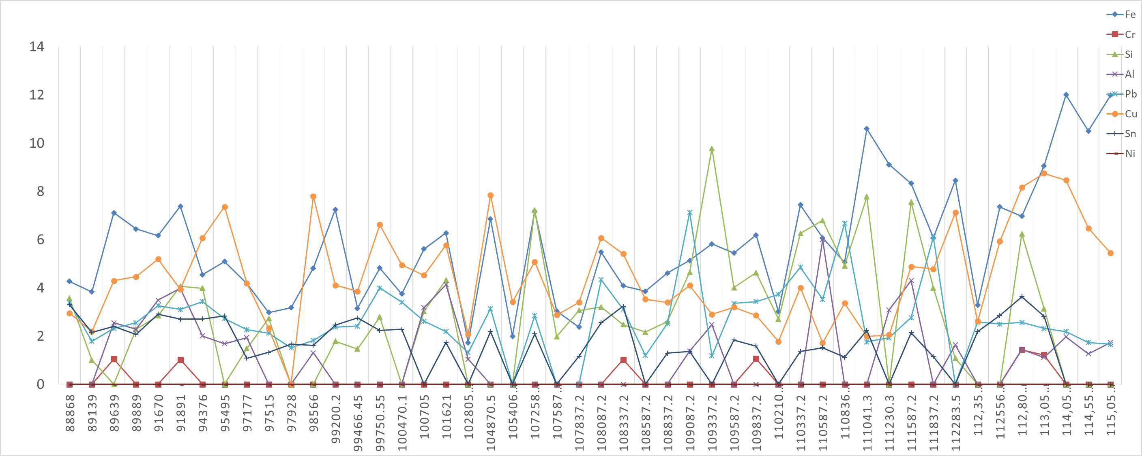

ppm

Total running hours

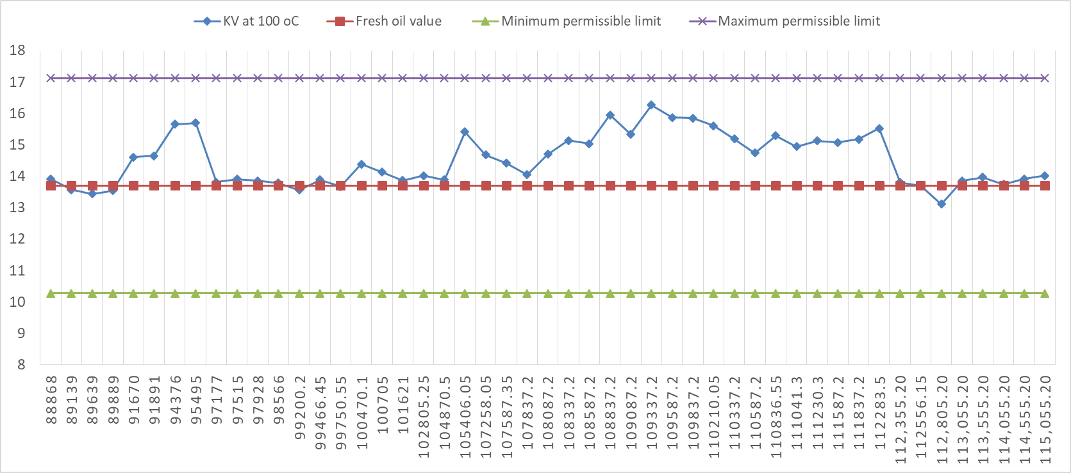
Viscosity
At 40⁰C

cSt

Total running hours

At 100⁰C

cSt

Total running hours

